**Business Type: Coffee shop (program for customers)**

**My Company Name: Student Technology**

Students and Coffee shops go together like peanut butter and jelly especially when stressful deadlines such as midterms, quizzes, projects, and the most stressful of all Finals.For students in the quarter system time flies buy however for a majority of their time it is spent in this crucial deadline stage. The quarter system consists of a ten week period followed by a week of finals. During this 11 week period around 60% is filled with assignments and tests. That is where student technology can help both coffee shops and coffee shop customers. With millennials rising with technology businesses need to contribute such technology to their customers. With rise of global competitors coffee shops need an edge in attracting customers. Their biggest customer during these stressful time frames are students. The average student takes 3-4 courses during a which adds up to 12-16 units averaging to over 25 hours of weekly studying required. If a coffee shop were to create an app for students offering deals and widgets designed for organization of their grades they would have an edge on their competitors. A program that will allow them to calculate their final exam grade necessary to achieve that “A” or even “C” in their course. This would allow students to organize and prioritize their studying and allow the coffee shops to offer deals that would allow them to want to study in their business establishment. Most students have a mobile phone and a program sponsored by a coffee shop will allow for great advertisement for one of their biggest markets. The program could grow to develop other tools that will benefit students and tutors anywhere in the world.

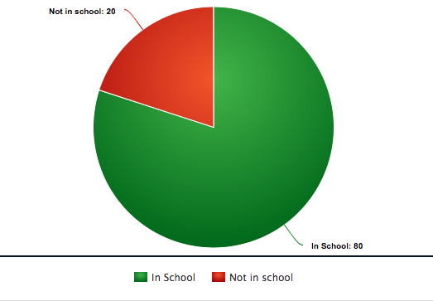

import java.util.Scanner;

public class FinalGrade {

public static void main(String[] args){

Double weight, current, required;

Double percentage;

Scanner inputNumScanner = new Scanner(System.in);

System.out.println("Enter the Final Exam Weight: ");

weight = inputNumScanner.nextDouble();

System.out.println("Enter Current Grade: ");

current = inputNumScanner.nextDouble();

System.out.println("Enter the grade you would like to receive? : ");

required = inputNumScanner.nextDouble();

percentage = (((required*.01) - ((1.0-(weight*.01))*(current*.01)))/ (weight*.01)) ;

System.out.println("The percentage required for the final is " + percentage*100 + " % " + "to receive a grade of " + required + "% in the class.");

}

}

